**Level 3 Core Maths**

**What will I need to study this course?**

You need to have at least a grade 4 in GCSE Mathematics. This can be from either the Foundation or Higher course.

**What will I study?**

This course is for students who want to learn more math but don't want to take the full A-level Mathematics course. It helps students who are studying other A-levels that use a lot of math. You will build on what you learned in GCSE and apply it to real-life situations. You will also learn some new skills at level 3.

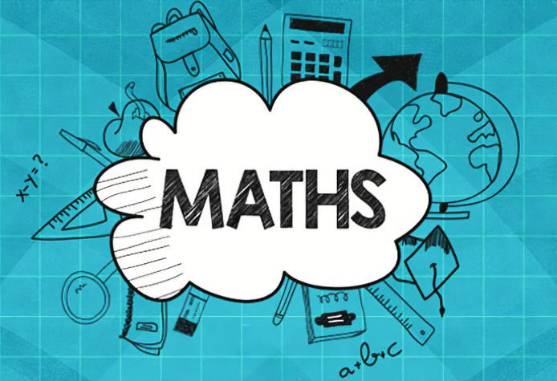The main focus is on using math and statistics to understand and solve real-world problems from different areas of study, work, and life.

Core Maths has three main goals:

1. Improve your math skills.

2. Help you feel more confident using math in real-life situations.

3. Develop skills in mathematical thinking and communication.

You will have 4 hours of lessons every two weeks.

**How is the course assessed?**

The whole course is assessed by exams. There will be two exams at the end of year 13.

**Where next?**

Core Maths is useful for further studies or careers that use a lot of maths.

[What can I do with a mathematics degree? | Prospects.ac.uk](https://www.prospects.ac.uk/careers-advice/what-can-i-do-with-my-degree/mathematics)

*Exam Board: Edexcel*

*QAN Code: 6014700/3*