A Level English Literature

What will I need to study this course?
You will need a love of reading and the ability to write extended responses.
You should have at least a grade 5 in both English Literature and English Language GCSE.

What will I study?
Core Texts: You will study six texts which you will be examined on:
- play: ‘Othello’ by William Shakespeare
- play: ‘A Streetcar Named Desire’ by Tennessee Williams
- novel: ‘The Great Gatsby’ by F. Scott Fitzgerald
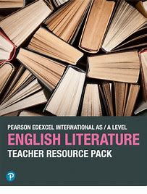
- novel: ‘The Handmaid’s Tale’ by Margaret Atwood
- poetry: ‘Feminine Gospels’ by Carol-Ann Duffy
- poetry: An anthology of pre-1900 poems
- You will also study unseen poetry and prose
- You will have unannotated copies of these texts in the exam (excluding ‘Othello’)
Exam Focus: You are required to analyse and compare some of these texts.

Challenges: You will do a lot of reading and research outside of lessons.

Skills Building: You will learn to interpret and compare a text’s themes, methods, and context. This will prepare you well to study literature at university.

How is the course assessed?
Exam: Paper 1: 40% - Love through the ages (3 hours)
Exam: Paper 2: 40% - Modern texts post-1945 (2 hours 30)
Coursework: 20% - You will write a 2500-word essay comparing two non-exam texts.

Where next?
This course can lead on to studying subjects involving communication, media, teaching, research, and many other jobs that need good reading, writing, or spoken skills.
What can I do with an English degree? | Prospects.ac.uk.
Exam Board: AQA
QAN Code: 7712 – 601/532/1

