**A Level Geography**

**“Geography is the subject that holds the key to our future” – Michael Palin**

**Why Geography?**

Geography tackles the big issues and enables us to make sense of them in our everyday lives:

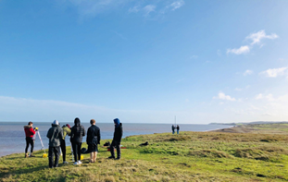**Environmental responsibility**

**Our global interdependence**

**Cultural understanding and tolerance**

**Commerce, trade and industry**

The human and physical world in which we live is likely to change more in the next 50 years than it has ever done before. Geography explains why this is and helps to prepare you for those changes.

**What will I need to study this course?**

A grade 5 or higher in GCSE geography is required. Consideration will be given to students who have met the general Sixth Form entry requirements and have not studied Geography at GCSE.

**What will I study and how is the course assessed?**

|  |  |  |
| --- | --- | --- |
| Content | Assessment | Marks |
| Physical Geography  -Water and carbon cycles  -Coastal systems and landscapes  -Hazards | Written exam. Y13 summer term  2 hours 30 minutes  120 marks | 40 % of A level |
| Human Geography  -Global systems and Governance  -Changing places  -Contemporary Urban Environments | Written exam. Y13 summer term  2 hours 30 minutes  120 marks | 40 % of A level |
| Geography Fieldwork Investigation | 3000-4000 words in class time and homework  60 marks | 20 % of A level |

Our four days of fieldwork on the north Norfolk coast combines the technical skills of teaching staff with a range of local, applied studies. Working with local contacts, we are proud of our eleven year history of collecting and tracking data.

**Where next?**

Geography is a facilitating subject and can help to gain places on a huge range of scientific and arts-based courses at University. It complements many other A level subjects and teaches transferable skills which makes geographers eminently employable in a wide variety of fields.

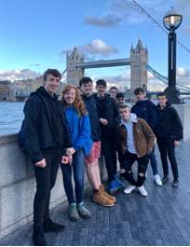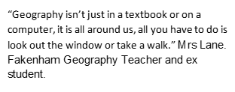

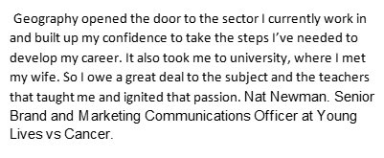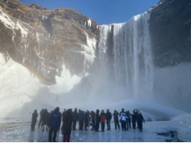

[Choose a career with geography - RGS](https://www.rgs.org/choose-geography/choose-a-career-with-geography)

[What can you do with a geography degree? | Top Universities](https://www.topuniversities.com/student-info/careers-advice/what-can-you-do-geography-degree#:~:text=What%20can%20you%20do%20with%20a%20geography%20degree%3F,geography%20...%208%20Landscape%20architect%20...%20More%20items)

[What can I do with a geography degree? | Prospects.ac.uk](https://www.prospects.ac.uk/careers-advice/what-can-i-do-with-my-degree/geography)

For further information please contact Mrs. Hirst – s.hirst@fakenhamacademy.org

*Exam Board: AQA*

*QAN Code: 7037*