**A Level Psychology**

**What will I need to study this course?**

To study Psychology, having a grade 5 or above in both GCSE Science and Maths is beneficial. Good written communication skills are also important, so having a Level 5 in English Language GCSE would be helpful.

**What will I study?**

**First Year Subjects:**

* Social Influence (Conformity & Obedience)
* Memory
* Attachment (Social Development in Children)
* Psychopathology (Mental Illness)
* Biopsychology
* Research Methods
* Approaches in Psychology

**Second Year Issues and Debates:**

* Issues and Debates in Psychology
* Gender
* Schizophrenia
* Forensic Psychology

**How is the course assessed?**

The course is assessed through three, two-hour examinations at the end of Year Two. These exams include multiple-choice, short answer, and long answer (essay) questions.

**Where next?**

Many students continue to study Psychology at degree level. Additionally, this course complements studies in Law, Sociology, Politics, Medicine, Health, Media, Journalism & Film, and other courses or careers involving the study of human behaviour.

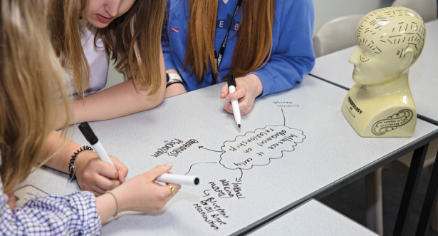[www.prospects.ac.uk/careers-advice/what-can-i-do-with-my-degree/psychology](http://www.prospects.ac.uk/careers-advice/what-can-i-do-with-my-degree/psychology)

*Exam Board: AQA*

*QAN Code: 601/4838/X*