# Summer Work – Transition from Year 11 to Year 12

BTEC Subject: Level 3 National Extended Certificate in Sport

Teacher name and Contact Email: Mrs V Dewson ([v.dewson@fakenhamacademy.org)](mailto:v.dewson@fakenhamacademy.org)

Required textbook: Revise BTEC National Sport Units 1 and 2 Revision Guide

ISBN: 9781292230535

Useful sources: [Careers in Sport | News, jobs and career advice for Sport](https://careers-in-sport.co.uk/)

[Careers advice - job profiles, information and resources | National Careers Service](https://nationalcareers.service.gov.uk/)

[Major Bones | Skeletal System 01| Anatomy & Physiology](https://www.youtube.com/watch?v=LMZStgTd-Tw&list=PLcdQDUUQX_4vcifsRu-iOyqZsxtlOsWxy)

Equipment List: A4 ringbinder (large), normal lesson stationary

# Tasks

As a sports fan I am sure you are very much looking forward to the sporting summer ahead with the British Lion’s Tour and the Women’s Euro’s football. I’m certain we will be talking about this for many years to come, however, I ask that this year, you look beyond this and ask some of the more pertinent questions concerning sport in the 21st century.

Can you complete the tasks below and bring them with you in September.

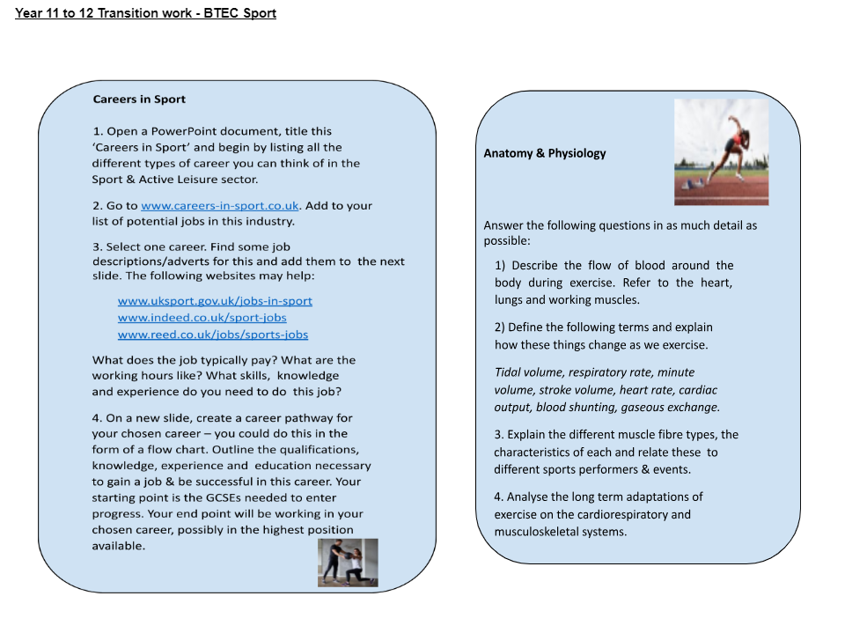Alongside the extensive theory content, the course will hope to offer plenty of opportunity for practical participation. This summer please play lots of sport, read about lots of sport and watch lots of sport. You have chosen this course because you have a passion and enthusiasm for sport. A key element of any future success is to maintain and develop this enthusiasm further.

Have a relaxing summer; I look forward to seeing you in September.