***Year 11 into 12 Transition Pack: BTEC Level 3***

BTEC Level 3 National

Extended Certificate in Music Performance



Year 11 > 12 Transition Pack

# BTEC Level 3 Music: Course Overview



At Fakenham Academy we run the Pearson BTEC Level 3 National Extended Certi**f**icate in Music Performance. This course is designed to develop your practical musicianship, musical literacy and knowledge and understanding of professional practice within the music industry. In addition to music-sector specific content, the course also explores highly desirable skills such as performance techniques, cognitive and problem-solving skills, communication skills, digital competency, self-management and collaborative team working.

It is expected that all applicants will play an instrument and/or sing and should aim to begin the course with a basic understanding of music theory and notation.

The qualification equates to one A level and is intended to be studied alongside other subjects over a two-year programme of study. Over the two year course course, you are expected to complete four units. Three are mandatory (highlighted below in orange) and you have one free choice.

|  |  |
| --- | --- |
| Unit | Mandatory/Optional |
| 1. Practical Music Theory and Harmony | Mandatory |
| 2. Professional Practice in the Music Industry | Mandatory |
| 3. Ensemble Music Performance | Mandatory |
| 4. Composing Music | Optional |
| 6. Solo Performance | Optional |
| 7. Improvising Music | Optional |

“Music gives a soul to the universe, wings to the mind, flight to the imagination and life to everything”

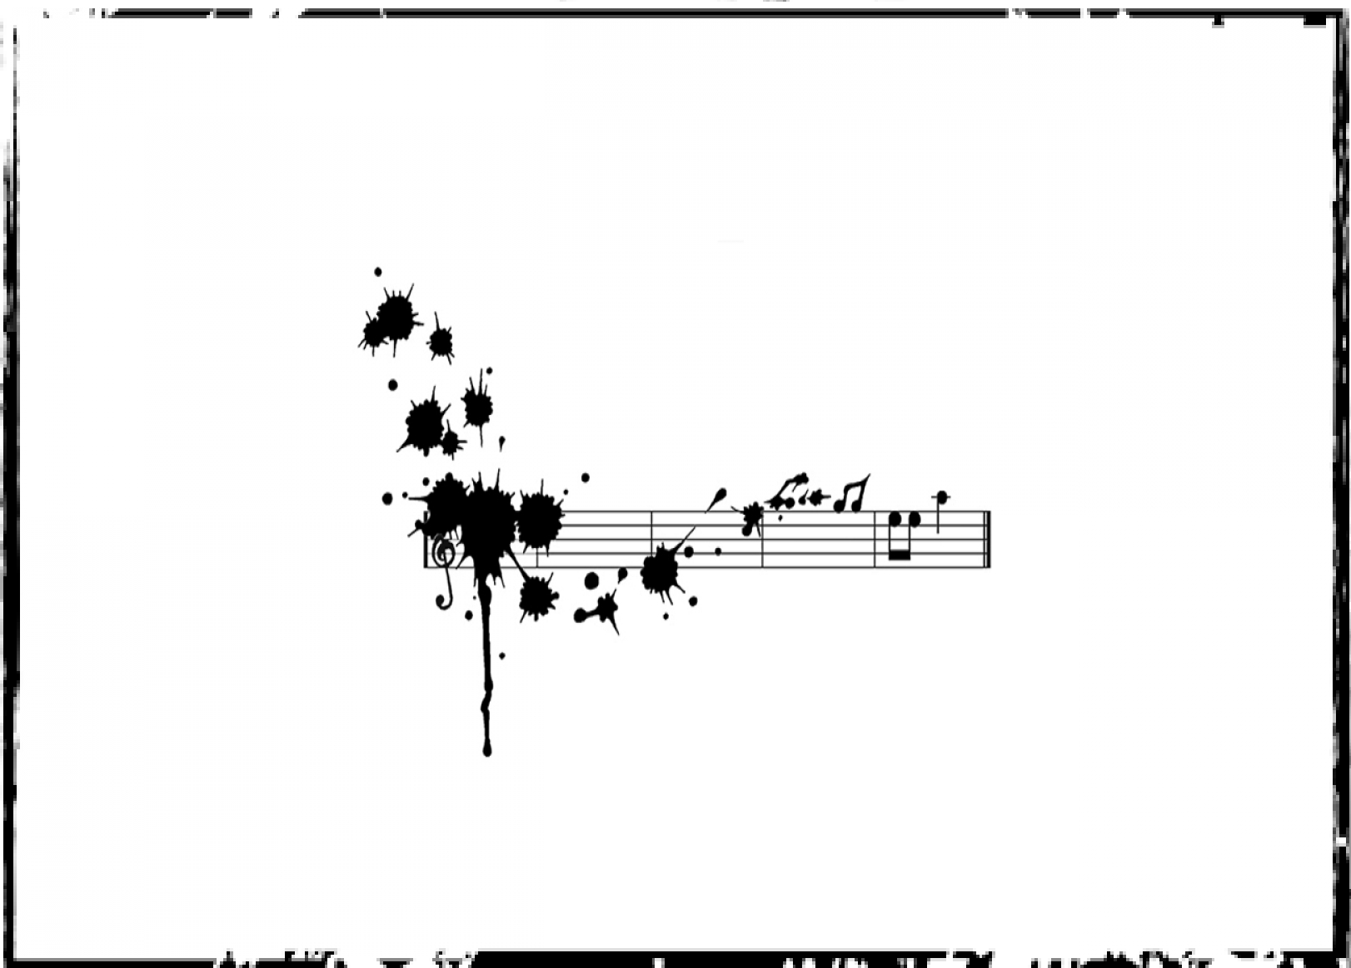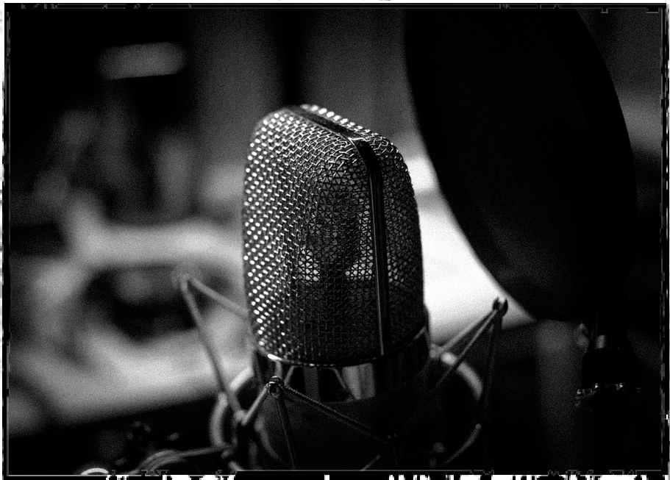

*- Plato*

## What is the aim of this transition project?

This transition project aims to give you an insight into some of the different Music BTEC units and give you a flavour of the type of tasks and project-based work you will be expected to complete during the course. This project has been designed to assess your musicianship, creativity, understanding of key professional attributes and ability to project manage.

Whilst the course is primarily practical, music industry professionals have acknowledged that it is extremely important for those pupils seeking to continue music in higher education, or pursue a career in the music industry, to understand music theory and notation. Being able to read and understand musical scores opens opportunities to those who do not read music. Therefore, this project also aims to give you a baseline knowledge of score and music reading.

***The transition project will include content based on:***

* + - Unit 1: Practical Music Theory and Harmony •
    - Unit 2: Professional Practice in the Music Industry • and
    - Unit 4: Composing Music or Unit 6: Solo Performance •

# **Project Tasks**

There is one short task and one extended task split into three sections that will culminate in the submission of one final portfolio. Each task should take you around three hours to complete.

|  |  |  |  |  |
| --- | --- | --- | --- | --- |
| **WEEK** | **PAGE** | **LEARNING AIM** | **TASK** | **SUBMISSION** |
| Week 1 | 5 | To know the basic signs and symbols of music notation  To understand where notes are placed on a stave  To be able to write a range of different note durations | Task 1: Music Theory | Music Theory Worksheets |
| Week 2 | 6-8 | To know the key professional attributes required at industry level To understand how positive professional relationships support career progression  To be able to identify strengths and weaknesses in relation to professional attributes | Task 2a: Extended Project - The Music Industry | Extended Project Portfolio that will include: |
| Week 3 | 9-10 | To know compositional or arrangement techniques  To understand how to resource and implement musical ideas  To be able to create an original or arranged musical product | Task 2b: Extended Project - Create a Music Product | * Professional behaviour audit * Recording of   music product |
| Week 4 | 11-12 | To know a range of marketing strategies  To understand how marketing can be used in different contexts  To be able to create a marketing portfolio | Task 2c: Extended Project - Market a Music Product | * Marketing plan |

Equipment Checklist

Pen/s Pencil/s Highlighters

Plain or Lined Paper Manuscript Paper Headphones

Composing or recording software on a computer, phone or tablet (i.e noteflight, garageband or just audio recordings).

## Week 1 - Task 1: Music Theory



Outline:

Before you begin your BTEC Level 3 Music in September, you will be in a very good position if you already have a basic understanding of music theory and notation. During this week you will learn and review some of the key aspects of music theory to get you started!

Task list:

1. Watch this short TED-Ed video on [‘How to read music’](https://www.youtube.com/watch?v=ZN41d7Txcq0). Take notes on how music notation identifies notes, pitch, clef, rhythm and bars.
2. Go through the lessons on [musictheory.net](https://www.musictheory.net/) based on the following topics -
   1. The staff, clefs and ledger lines
   2. Note duration
   3. Measures and time signature
   4. Rest duration
   5. The major scale
   6. The minor scale
   7. Key signatures

Take detailed notes on each area and practice writing out your clefs and notes. If you require manuscript paper (paper that has staves on), you can print from [this](https://makingmusicfun.net/public/assets/pdf/blanks/BlankStaffPaper.pdf) website, but you can also draw out your own using a ruler. You can also do tests on this website to check your knowledge!

Submission:

Complete the 7 worksheets on the next few pages which will be marked in September.

|  |  |
| --- | --- |
| Extra links and resources | Estimated Time |
| Music Theory for Dummies | 3 hours |
| BBC Bitesize Music Notation |
| Building Blocks YouTube Channel (Music Theory) |

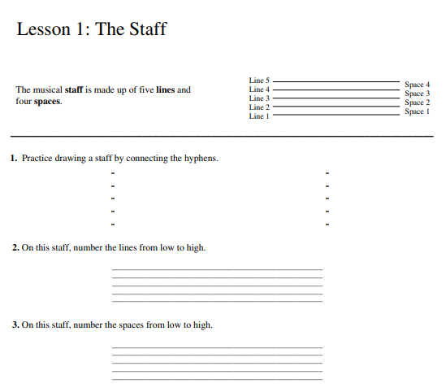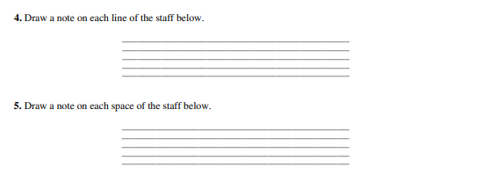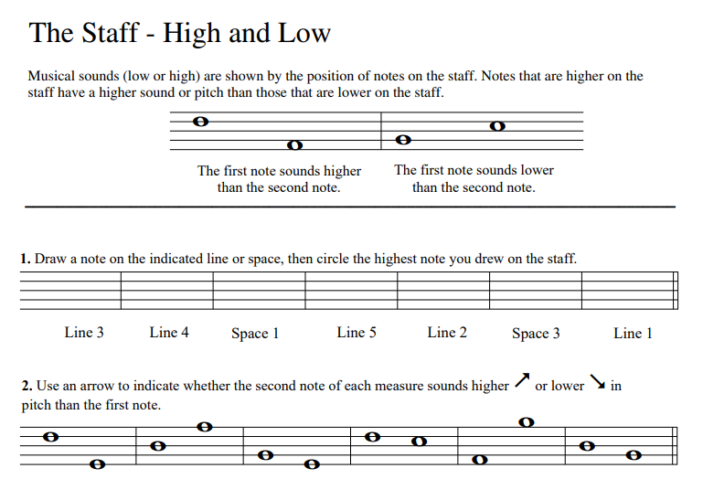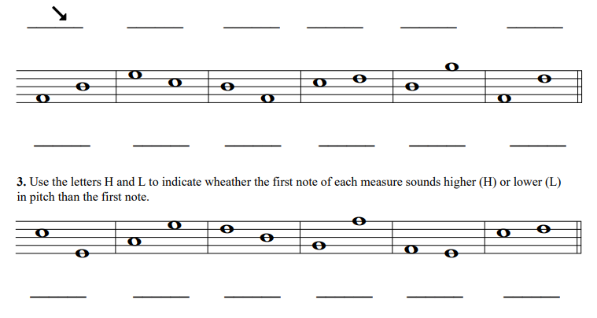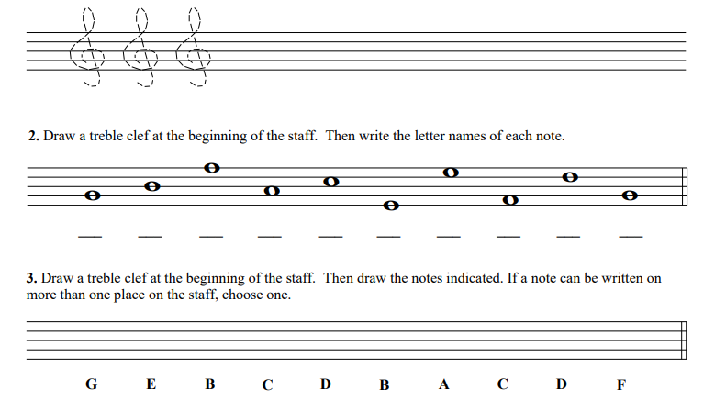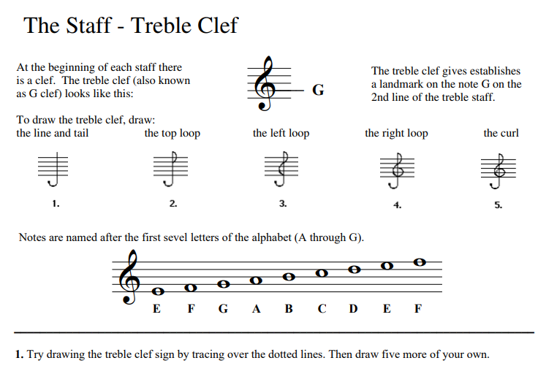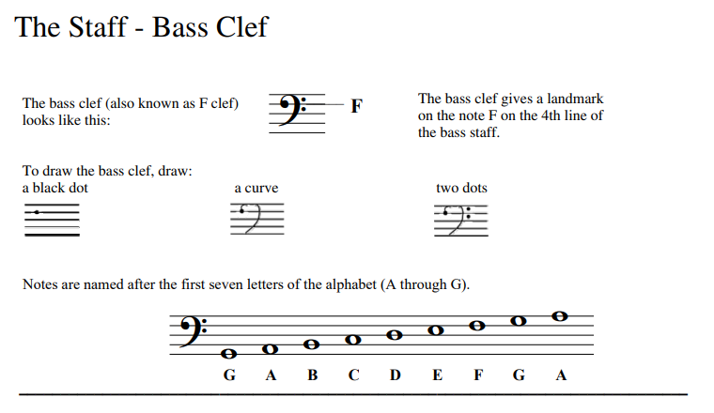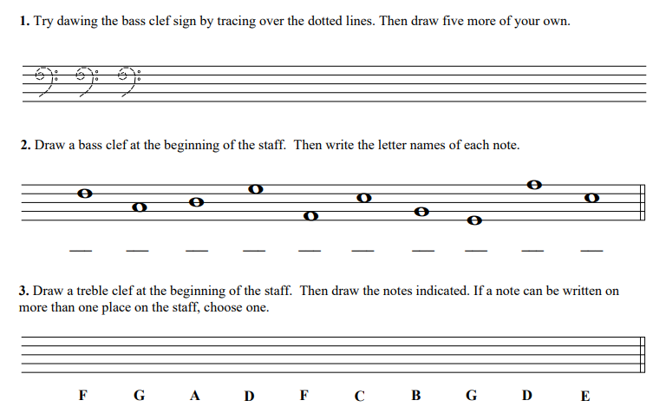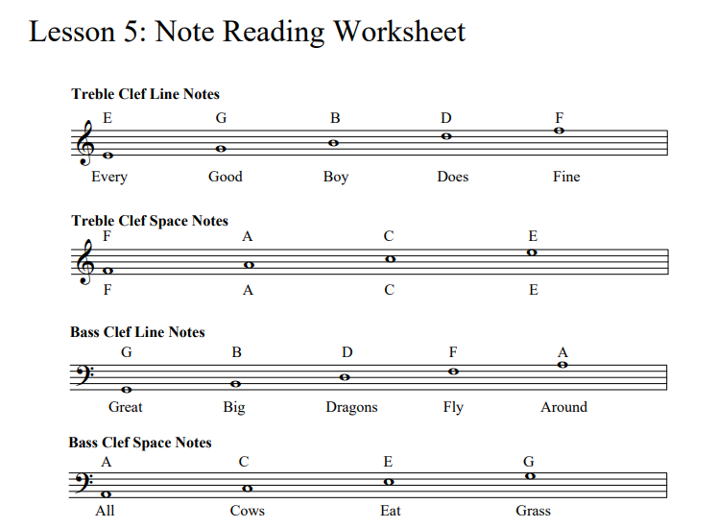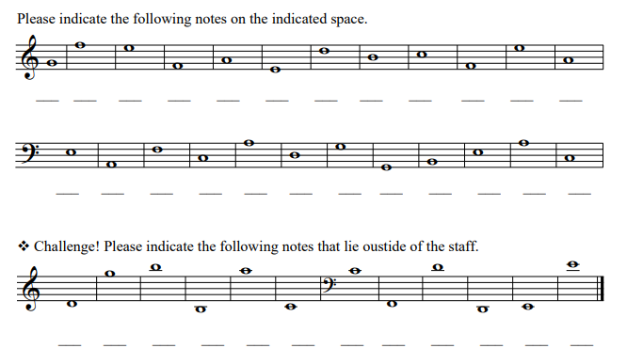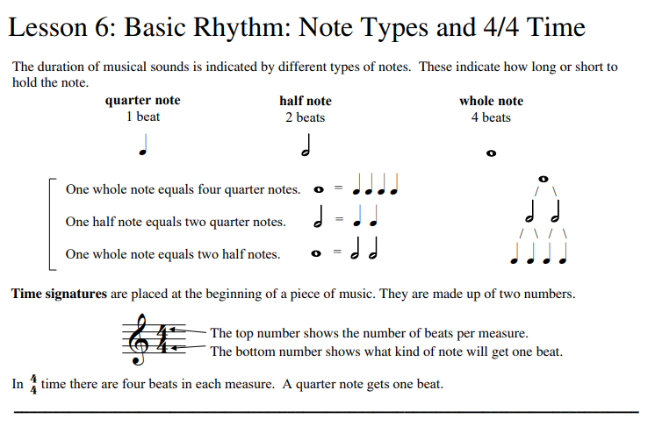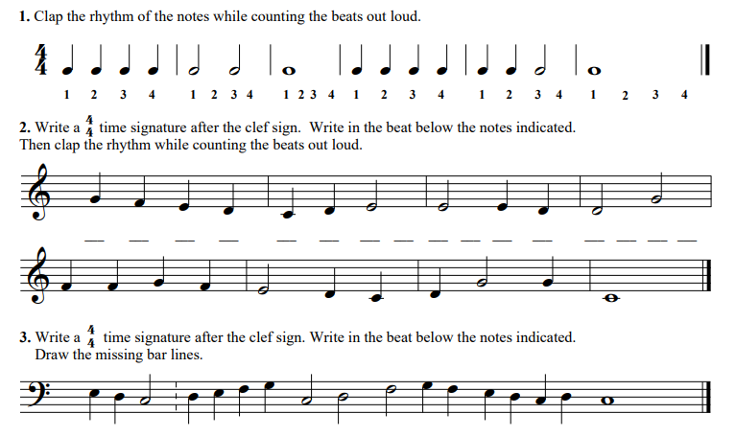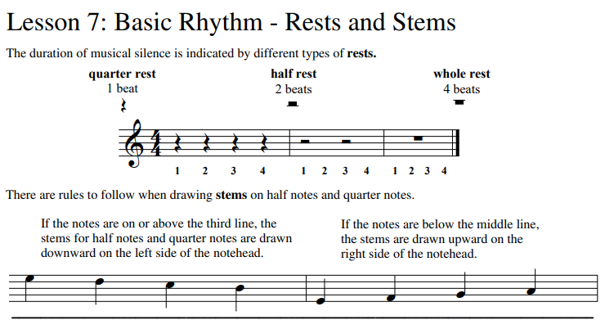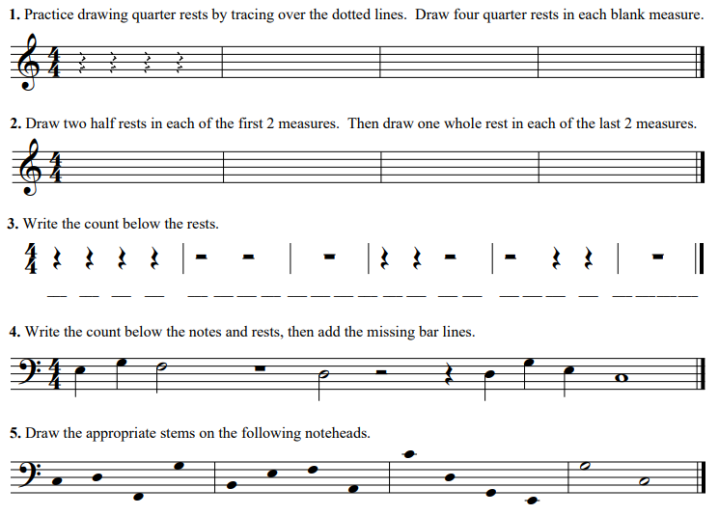

## Week 2 to 4 - Task 2: Extended Project



Outline:

For your extended music project, you will learn about some important aspects of the music industry, create a music product, and plan a marketing campaign for your music product in line with expected professional practice. This task is split into three subsections and should take you three weeks to complete.

Task list:

There are a set of different tasks within each subsection (2a, 2b and 2c). Follow the instructions and keep a record of your notes as this will help you create your final portfolio!

Submission:

A portfolio of work that includes - a professional behaviour audit, a recording of your music product and marketing package. See Appendix A for more details.

|  |  |  |
| --- | --- | --- |
| Task | Extra links and resources | Estimated Time |
| 2a - The Music Industry | Music Industry | 2 hours |
| Current Issues in the Industry |
| How the Music Industry Works |
| 2b - Create a Music Product | Beginners guide to Music Production | 4 hours |
| Online beat maker |
| What makes a song a hit? |
| 2c - Market a Music Product | Marketing Tips | 3 hours |
| How to grow your fanbase |
| Outstanding examples of modern marketing |

### Week 2 - Task 2a: The Music Industry



Building a successful and profitable career in the music industry relies on good professional practice. Maintaining a professional demeanor, behaving appropriately, and building positive working relationships is something that is learnt very quickly; reputation is everything! It is often said that excellent communication skills are just as important as creating a good product.

Most industry professionals are freelance workers. This means that they are self-employed and rely on being hired for work by different companies or personnel and most do not have a reliable regular income. Whilst there are many advantages to ‘being your own boss’ it can also be an extremely tough gig when you are solely responsible for sourcing clients (a customer/person/company using your services), arranging and managing your finances and funding, whilst maintaining a high-quality product.

However, in addition to this, job roles, expectations, developments and products change rapidly within this sector, and it is extremely important that musicians, technicians and engineers alike aim to keep on top of current trends and ways of working. Large amounts of persistence, resilience and self-belief (and ability to self-reflect) are crucial to success in this industry. Other important skills are the ability to negotiate, network, build relationships and form an online presence.

Watch [this](https://www.youtube.com/watch?v=aqz3DaisBz8) documentary on ‘The Music Industry and the Digital Revolution’. Key questions (take notes on the pages following this – you don’t have to fill the space):

* What has changed in the industry over time?
* What are the challenges with the business model?
* What do you think is the most important thing to be successful?
* Any other considerations

_________________________________________________________________________________________________________________________________________________________________________________________________________________________________________________________

_________________________________________________________________________________________________________________________________________________________________________________________________________________________________________________________

_________________________________________________________________________________________________________________________________________________________________________________________________________________________________________________________

_________________________________________________________________________________________________________________________________________________________________________________________________________________________________________________________

_________________________________________________________________________________________________________________________________________________________________________________________________________________________________________________________

_________________________________________________________________________________________________________________________________________________________________________________________________________________________________________________________

_________________________________________________________________________________________________________________________________________________________________________________________________________________________________________________________

_________________________________________________________________________________________________________________________________________________________________________________________________________________________________________________________

_________________________________________________________________________________________________________________________________________________________________________________________________________________________________________________________

_________________________________________________________________________________________________________________________________________________________________________________________________________________________________________________________

_________________________________________________________________________________________________________________________________________________________________________________________________________________________________________________________

___________________________________________________________________________________________________________________________________________________________________________________________________________________________________________________________________________________________________________________________________________________________________________________________________________________________________________________________________________________________________________________________________________________________________________________________________________________________________________________________________________________________________________________________________________________________________________

_________________________________________________________________________________________________________________________________________________________________________________________________________________________________________________________

_________________________________________________________________________________________________________________________________________________________________________________________________________________________________________________________

_________________________________________________________________________________________________________________________________________________________________________________________________________________________________________________________

_________________________________________________________________________________________________________________________________________________________________________________________________________________________________________________________

_________________________________________________________________________________________________________________________________________________________________________________________________________________________________________________________

**Additional thoughts…**

Read these articles about the music industry and add to your notes - do you agree with everything that has been written? What are some of the issues facing the music industry?

[The Music Industry Facts Every Musician Needs to Know (liveabout.com)](https://www.liveabout.com/music-industry-facts-every-musician-needs-to-know-2460726)

[Employability - BIMM Music Institute](https://www.bimm.ac.uk/employability/)

[The Fall of The Music Industry, Where It Is and Where It’s Going | by Hayden Jennings | Medium](https://medium.com/@HaydenJenning18/the-fall-of-the-music-industry-where-it-is-and-where-its-going-dd12da6427ff)

Task: Professional behaviours audit

1. Go through the list of desirable professional behaviour’s (below). Reflect on why each behaviour is important and the value it could bring to an industry professional.
2. Then RAG yourself against each behaviour – how well do you think you could show these skills? Are there some you need to improve on?

**Desirable, professional behaviours:**

* + Being prepared, reliable and committed
  + Being organised and plan using prioritisation skills
  + Excellent communication and awareness of others
  + Excellent punctuality, able to meet deadlines and considered scheduling
  + Able to work in teams, knows when to take the lead or delegate
  + Achieves excellent outcomes and good at making decisions

**Task: Job roles in the industry**

1. Read through [this](https://www.ukmusic.org/wp-content/uploads/2021/05/UK_Music_Careers_Information_Pack_2020.pdf) information about jobs in the industry.
2. Choose 4 roles which interest you and research them in more detail. Find out:

* what the main responsibilities are
* how you might apply for this kind of job (is it freelance or contract?)
* what other job roles it connects with
* why this role is important to the industry
* what professional attributes are required to be successful in this position

This should be recorded onto a powerpoint presentation and shared with k.adams@fakenhamacademy.org.

### Week 3 - Task 2b: Create a Music Product



Now we get to the fun bit! You have been given a brief to create a music product.

The brief is to: record a piece of music that will bring the community together.

This can be an original song, rap, instrumental or a cover version of an already existing piece that you believe fits the brief (it does not have to be pop, it can be classical!). In other words, you can write and record your own piece, or choose to learn another piece which fits the brief. The piece can be recorded live (using whatever recording device you have at home)

Before you get started:

1. It is essential to consider what makes an uplifting piece of music, or music that might bring a community together. Listen to the tracks listed below (all have been used to bring people together) and think carefully about the musical features within them. Write down a list of the following musical aspects:
   1. The key - is it major or minor (does it sound happy or sad)
   2. The instruments - what kinds of sounds are used, how does this link with the aim of the music?
   3. The tempo - is it fast or slow?
   4. The dynamics - is it loud or quiet? Does it change at all?
   5. Any other important points.

[Read All About It, Pt. III - YouTube](https://www.youtube.com/watch?v=kRvqkhVFC7M)

[Live Lounge Allstars - Times Like These (BBC Radio 1 Stay Home Live Lounge) (youtube.com)](https://www.youtube.com/watch?v=7GElP4YdrBE)

1. What musical features are common across all these songs? Why do you think that is? Write down your answers.
2. Do your own research into different pieces and songs that you think bring communities together. Write down a list of the pieces you have found/you like and their musical features.
3. Decide if you are going to create your own piece, or do a cover version. Your piece does not have to be

Here is a good song structure that can be used for traditional songs, but also for raps and instrumentals.

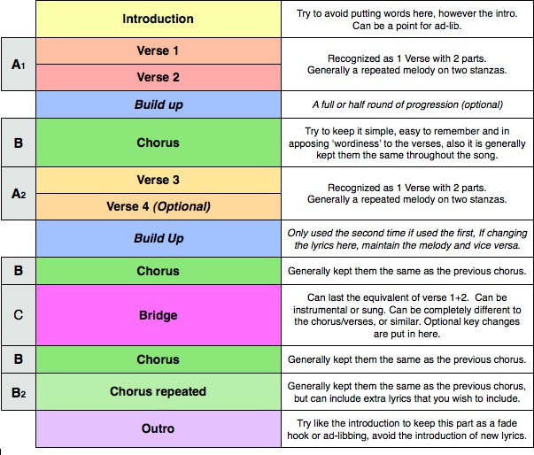

1. Write and record part, or all, of your piece of music ready for your final submission.

_________________________________________________________________________________________________________________________________________________________________________________________________________________________________________________________

_________________________________________________________________________________________________________________________________________________________________________________________________________________________________________________________

___________________________________________________________________________________________________________________________________________________________________________________________________________________________________________________________________________________________________________________________________________________________________________________________________________________________________________________________________________________________________________________________________________________________________________________________________________________________________________________________________________________________________________________________________________________________________________

_________________________________________________________________________________________________________________________________________________________________________________________________________________________________________________________

_________________________________________________________________________________________________________________________________________________________________________________________________________________________________________________________

_________________________________________________________________________________________________________________________________________________________________________________________________________________________________________________________

_________________________________________________________________________________________________________________________________________________________________________________________________________________________________________________________

_________________________________________________________________________________________________________________________________________________________________________________________________________________________________________________________

_________________________________________________________________________________________________________________________________________________________________________________________________________________________________________________________

_________________________________________________________________________________________________________________________________________________________________________________________________________________________________________________________

___________________________________________________________________________________________________________________________________________________________________________________________________________________________________________________________________________________________________________________________________________________________________________________________________________________________________________________________________________________________________________________________________________________________________________________________________________________________________________________________________________________________________________________________________________________________________________

_________________________________________________________________________________________________________________________________________________________________________________________________________________________________________________________

_________________________________________________________________________________________________________________________________________________________________________________________________________________________________________________________

_________________________________________________________________________________________________________________________________________________________________________________________________________________________________________________________

_________________________________________________________________________________________________________________________________________________________________________________________________________________________________________________________

### Week 4 - Task 2c: Market a Music Product



The music industry is changing and with the increase of streaming platforms it is growing increasingly important for musicians and record labels to market their products using a variety of different means, mostly online. Marketing and advertising your product will involve carrying out appropriate research (target audience), devising a creative approach and meeting those all-important deadlines.

A good marketing campaign can have a huge impact on the success of an artist’s future. For example, the Red Hot Chilli Peppers planned a comeback tour in 2018 after many years out of the game. Their strategy was to litter facebook, instagram, instagram stories, Spotify takeovers of ‘best hits’ and sponsorships. They spread their logo and sounds far and wide in a bid to refresh audiences love for their music and get tickets selling! The uplift on Spotify during the campaign period was really positive and the numbers of people streaming their music doubled!

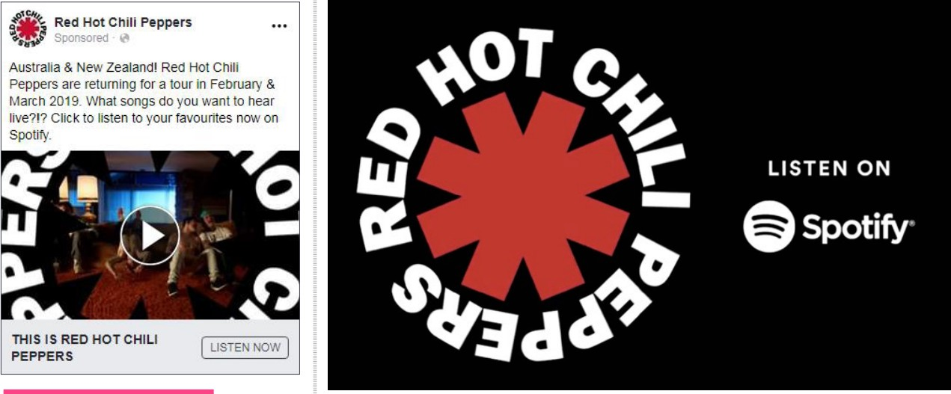

Another successful strategy, *that occurred by mistake*, was the Drake ‘Hotline Bling’ meme. Although, it’s very hard to make something go viral when you plan it!

1. Read [this](https://www.musicindustryhowto.com/music-marketing/) ‘how to’ guide on music marketing. And watch [this](https://www.youtube.com/watch?v=bj3kWAKaLvc) video. Key question:
   * What are the top three strategies of music marketing and why?

_________________________________________________________________________________________________________________________________________________________________________________________________________________________________________________________

_________________________________________________________________________________________________________________________________________________________________________________________________________________________________________________________

_________________________________________________________________________________________________________________________________________________________________________________________________________________________________________________________

_________________________________________________________________________________________________________________________________________________________________________________________________________________________________________________________

1. Establish who your main target audience is and write a ‘profile’ of a typical fan. Who are they? Where do they live? How old are they? What do they like to do with their spare time? Where do they hang out?

_________________________________________________________________________________________________________________________________________________________________________________________________________________________________________________________

_________________________________________________________________________________________________________________________________________________________________________________________________________________________________________________________

_________________________________________________________________________________________________________________________________________________________________________________________________________________________________________________________

_________________________________________________________________________________________________________________________________________________________________________________________________________________________________________________________

1. For the purpose of this task, you need to focus on two main marketing strategies for your music product. [This](https://musically.com/wp-content/uploads/2018/12/Sandbox218-EOY-47927645739.pdf) is the 2018 Sandbox Music Marketing awards and might give you some additional ideas. Your list could include the following:
   * Poster/flyers
   * Instagram account
   * X account
   * Radio advert
   * Music video
   * Youtube channel
   * Snapchat
2. Think carefully about the imagery, colours and font. Ensure you are able to justify and give a clear rationale for your choices.
3. Design, create and outline your strategy. Present this clearly and add to your portfolio. This can be a powerpoint presentation.

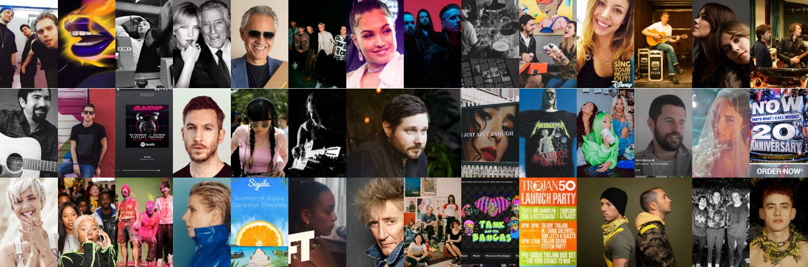

### Appendix A: The Portfolio

Your portfolio will be a collection of the work you have created during your extended project, tasks 2a, 2b and 2c. It will form a music ‘pitch’ and can be presented in a format of your choice - it could be a powerpoint, it could be a movie, it could be a collection of word or handwritten documents with an mp3, it could be a website! You can write it, you can speak it. It is up to you. The more unique, the better.

The aim of the portfolio is to demonstrate your understanding of key music industry protocols and your creative approach to the brief, as well as justify the decisions that you made during the creative process, and will highlight any areas you would like to develop further.

Sections you need to include:

* Your music product (audio format)
* A description and evaluation of your music product including why this music product and how you believe it fits the brief. Make reference the tracks that you listened to and researched.
* Market ‘Research’ - who is your target audience and why is your product appealing to them?
* Marketing package - examples of instagram stories and/or flyers etc.
* Rationale for approach to marketing making reference to modern industry practice, issues in the music industry and how you seek to overcome them.
* Professional behaviour audit.

Throughout your portfolio you should seek to demonstrate professional industry practice through:

* Meeting deadlines
* Demonstrating excellent communication
* Demonstrating an ability to build positive relationships
* Sense of resilience and ability to overcome issues.

Good luck!

[mmishurenko@lambeth-academy.org](mailto:mmishurenko@lambeth-academy.org)