# Summer Work – Transition from Year 11 to Year 12

# A Level Subject: Psychology

Teacher name and Contact Email: Mrs Marshall-Smith [l.marshall-smith@fakenhamacademy.org](mailto:l.marshall-smith@fakenhamacademy.org)

Required textbook: AQA Psychology for A Level : Year 1 and AS Third edition

**Author(s):** Cara Flanagan, Matt Jarvis and Rob Liddle

[AQA Psychology for A Level : Year 1 and AS Third edition | Hachette Learning](https://www.hachettelearning.com/psychology/aqa-psychology-for-a-level-year-1-and-as-third-edition)

# AQA Psychology for A Level: Year 2 Third edition

**Author(s):** Cara Flanagan, Matt Jarvis, Rob Liddle, Tom Buxton-Cope and Mandy Wood

[AQA Psychology for A Level: Year 2 Third edition | Hachette Learning](https://www.hachettelearning.com/psychology/aqa-psychology-for-a-level-year-2-third-edition)

Useful sources:

[AQA | Psychology | A-Level | A-level Psychology](https://www.aqa.org.uk/subjects/psychology/a-level/psychology-7182/specification)

[Psychology | tutor2u](https://www.tutor2u.net/psychology)

[Psych Boost - YouTube](https://www.youtube.com/channel/UCqqIPOTshm8EM8CCWkCy9Pg)

[Study Guides for Psychology Students - Simply Psychology](https://www.simplypsychology.org/)

Equipment List:

Three A4 Lever Arch Files.

Pens, paper, ruler, highlighters and a calculator

# Tasks

In order to prepare you for A level studies, you are required to complete a range of activities which develop your knowledge and independent study skills. Bring these to your first lesson and we will take them and give you feedback on them

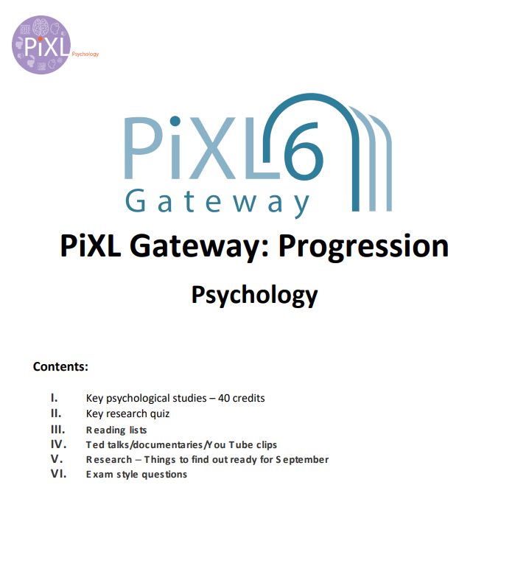

## Key Psychological Studies

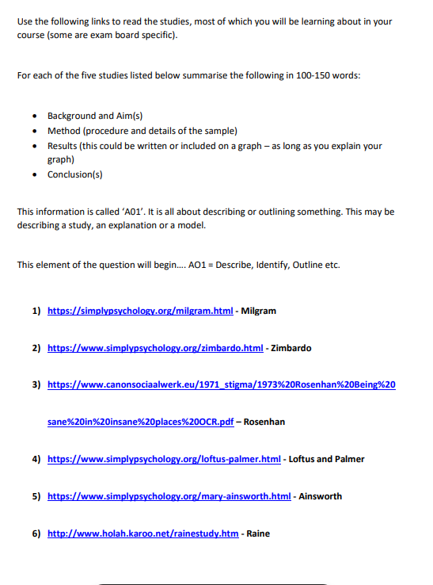

## Key Studies Quiz

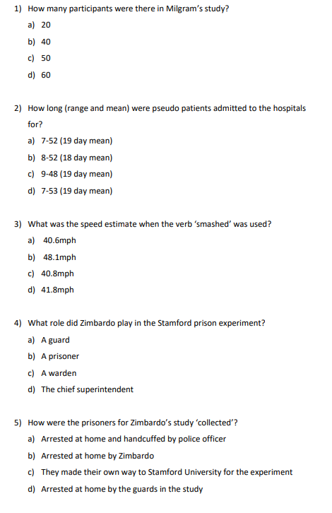

## Reading List

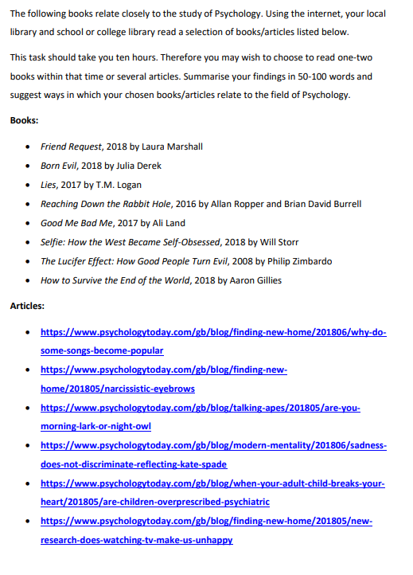

## Ted Talks, Documentaries and YouTube Clips

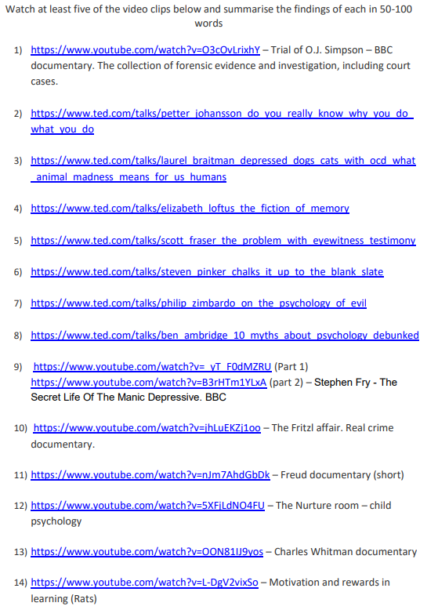

## Research – five things to find out ready for September

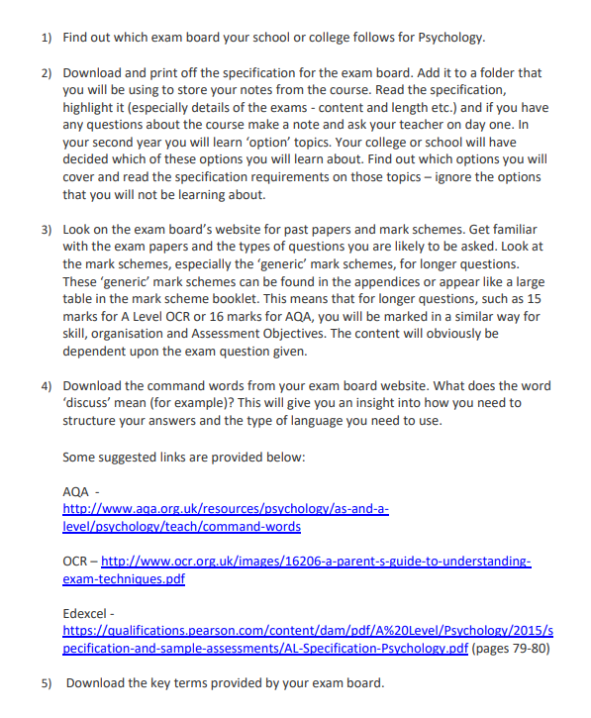

## Exam Style Questions

